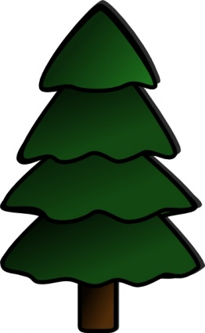 PULLED
PORK 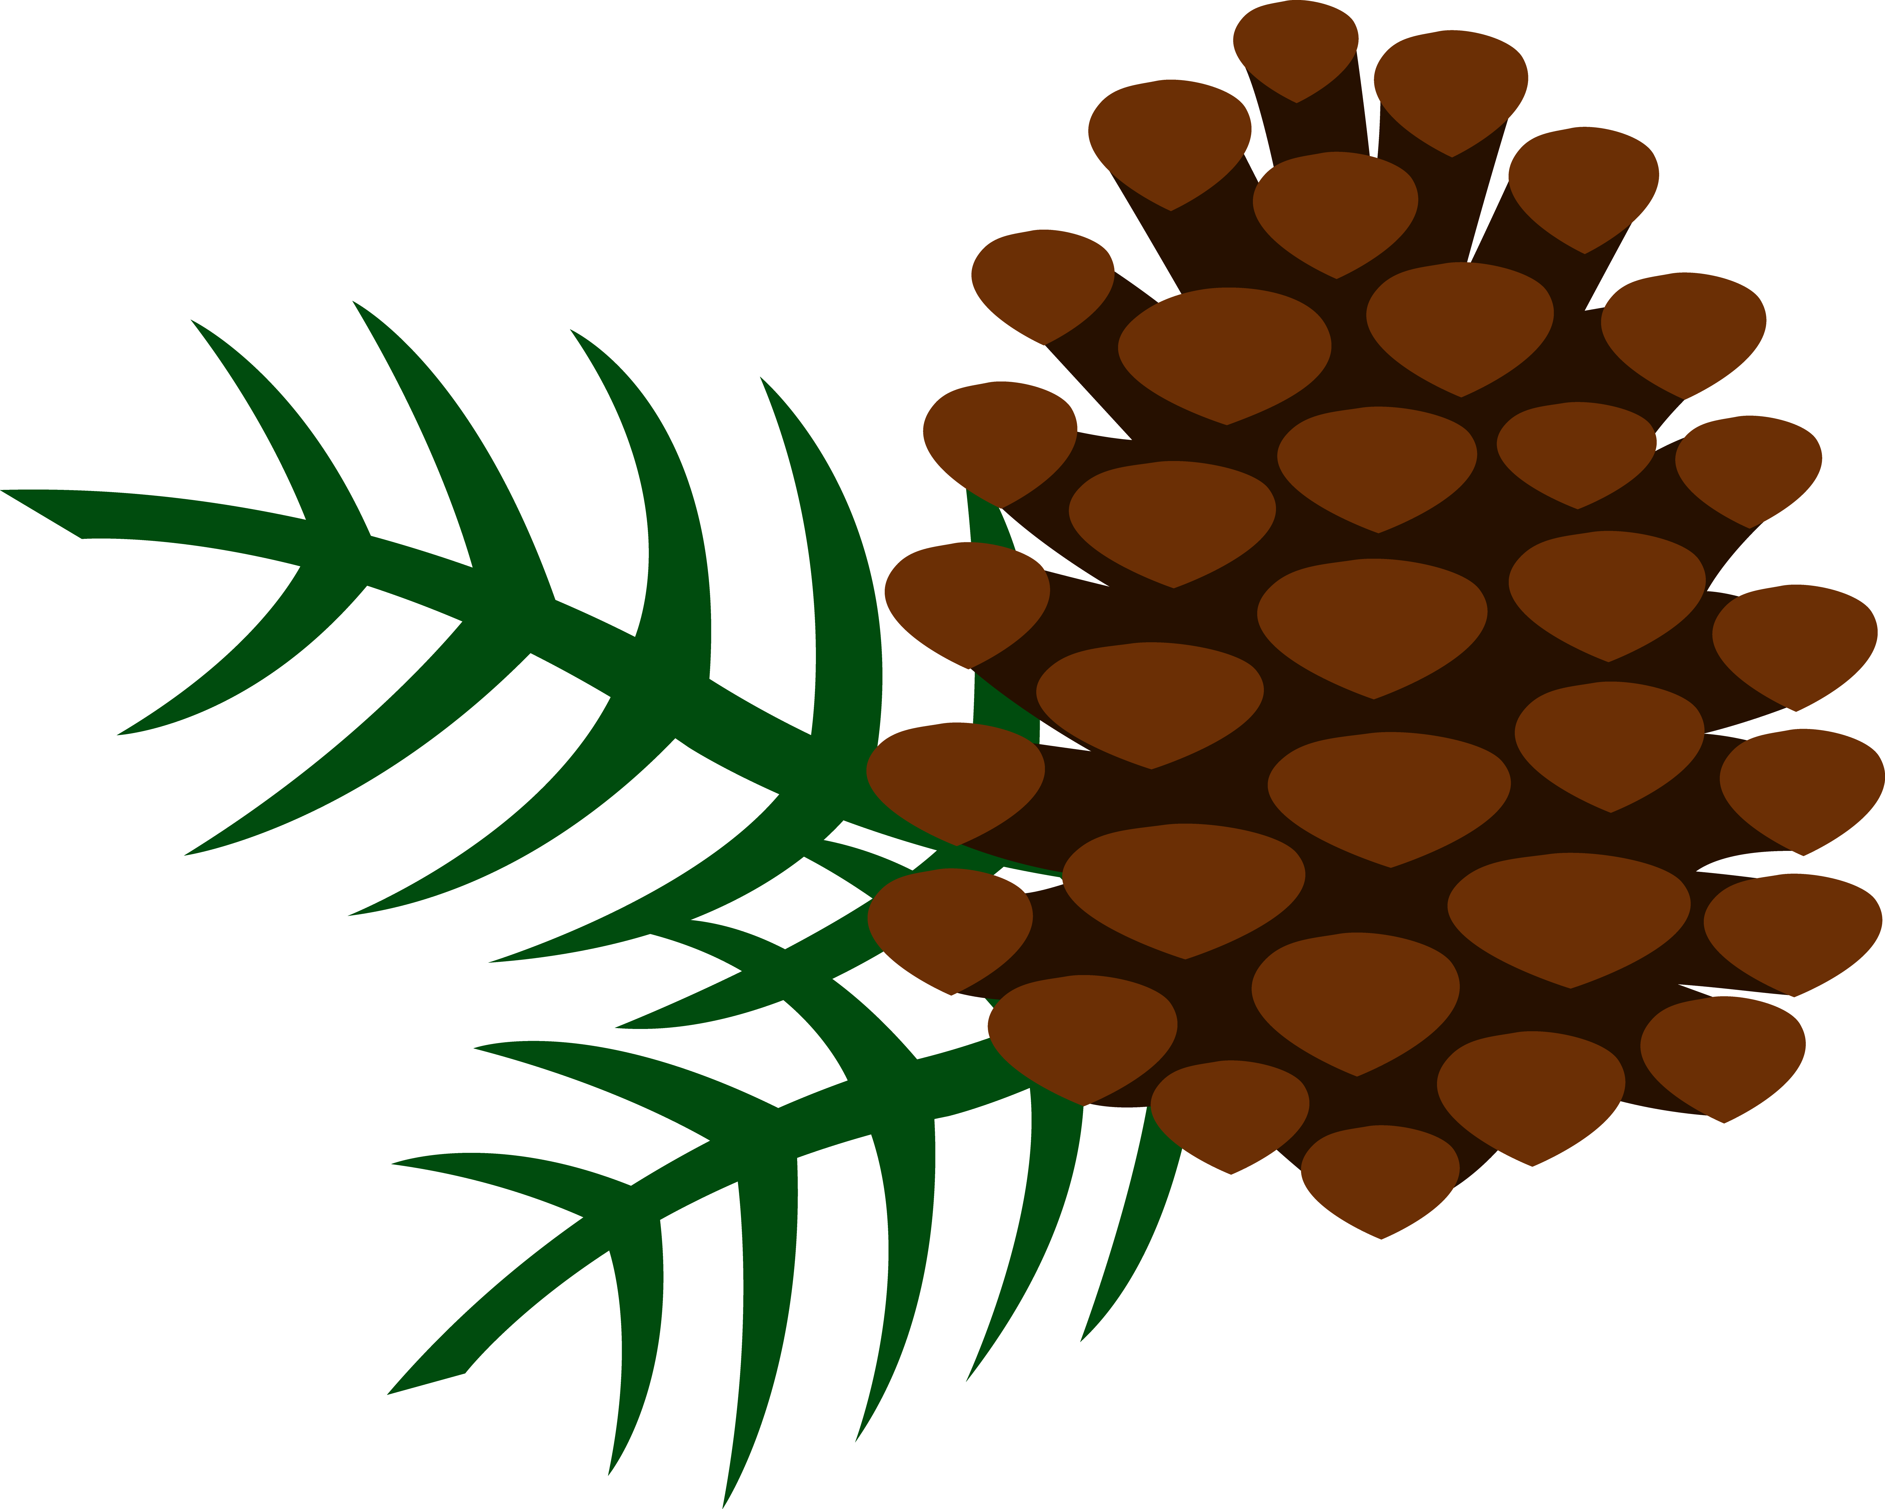

TRAILMIX

HOTDOG FIXIN’S

S’MORE
POPS

SPRING
WATER

FIRE
LOGS

MAPLE
LEAVES

FISHING
BAIT

WILD
BERRIES

DEER
POOP

CAMPFIRE
FLAMES

S’MORE
TRAILMIX

MATCH
STICKS

BEAR
PAWS

