Melted Snowman Drink  3 oz Eggnog (or milk)  1 oz Bailey’s  1 oz Caramel Flavored Vodka  Pour ingredients into snowman glass over ice. Mix well and enjoy! | 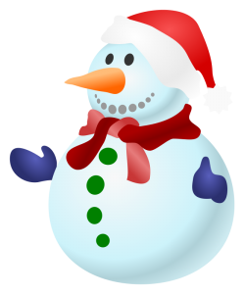

Melted Snowman Drink

3 oz Eggnog (or milk)
1 oz Bailey’s
1 oz Caramel Flavored Vodka

Pour ingredients into snowman glass over ice. Mix well and enjoy!

