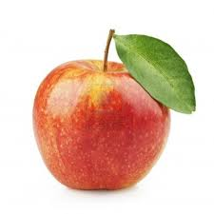**Apple Taste Test**

|  |  |  |  |  |  |  |  |  |
| --- | --- | --- | --- | --- | --- | --- | --- | --- |
| **Granny Smith** |  |  |  |  |  |  |  |  |
| **Red Delicious** |  |  |  |  |  |  |  |  |
| **Honey Crisp** |  |  |  |  |  |  |  |  |
| **Gold Delicious** |  |  |  |  |  |  |  |  |
| **Pink Lady** |  |  |  |  |  |  |  |  |
| **Gala** |  |  |  |  |  |  |  |  |
|  | **Green** | **Red** | **Yellow** | **Mixed** | **Sweet** | **Sour** | **I like it ☺** | **I don’t like it ☹** |