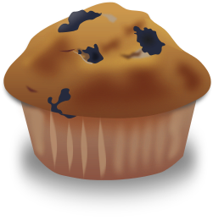

If You Give a Mom a Muffin

Author: Beth Brubaker

If you give a mom a muffin,  she'll want a cup of coffee to go with it.  She'll pour herself some.  Her three-year-old will spill the coffee.  She'll wipe it up.  Wiping the floor, she'll find dirty socks.  She'll remember she has to do laundry.  When she puts the laundry in the washer,  she'll trip over boots and bump into the freezer.  Bumping into the freezer will remind her  she has to plan for supper.  She will get out a pound of hamburger.  She'll look for her cookbook  ("101 Things To Do With a Pound of Hamburger").  The cookbook is sitting under a pile of mail.  She will see the phone bill, which is due tomorrow. | She will look for her checkbook.  The checkbook is in her purse  that is being dumped out by her two-year-old.  She'll smell something funny.  She'll change the two-year-old's diaper.  While she is changing the diaper,  the phone will ring.  Her five-year-old will answer and hang up.  She'll remember she wants to phone a friend  for coffee.  Thinking of coffee will remind her  that she was going to have a cup.  And chances are...  If she has a cup of coffee,  her kids will have eaten the muffin that went with it.

