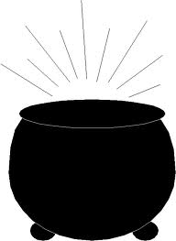

**p o t**

**__ __ __**

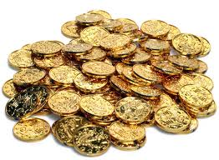

**g o l d**

**__ __ __ __**

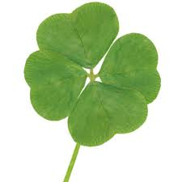

**l u c k**

**__ __ __ __**



**g r e e n**

**__ __ __ __ __**