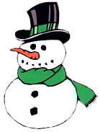

Snowman Soup!
When the weather outside is frightful,
“Snowman Soup” is so delightful!
May it warm your spirit and your soul.
Let it snow! Let it snow! Let it snow!

When you feel a chill or a “brrrrr,”
Use the peppermint stick to stir.
Add hot water and sip it slow.
Let it snow! Let it snow! Let it snow!

